
CANTEEN FOOD PREPARATION WITH FOCUS ON SALES PATTERN ANALYSIS FOR DAILY MEAL PLANNING ACCURACY

SYSTEM DOCUMENTATION

SUBMITTED BY,
LUKE KIOKO
DDA-03-0070/2024

A SYSTEM DOCUMENTATION SUBMITTED IN PARTIAL FULFILMENT FOR THE AWARD OF DIPLOMA IN DATA SCIENCE AND ANALYTICS BY ZETECH UNIVERSITY

DEC, 2025

DECLARATION
This project documentation is fully my own work. Any outside sources I used have been properly referenced. Nothing here is plagiarized and this exact document hasn’t been submitted anywhere else. It is an original report prepared as part of my Diploma in Data Science and Analytics at Zetech University.
Student Name: ____________________________ Sign: _________________ Date: __________
Supervisor Name: _________________________ Sign: _________________ Date: __________

DEDICATION
I dedicate this project to my sister, Tabitha Mutheu. Her support, encouragement, and belief in me have kept me going and helped me finish this work.

ABSTRACT
This project took four months and involved building a Canteen Management System. It was made using Python, Streamlit for the interface, Pandas and NumPy for data work, and Plotly for charts. Login and roles were handled using a SimpleAuth module, and data was saved in Excel and JSON files. The system was created to fix the problems caused by manual record-keeping, like errors and poor accountability. Admins can manage users, staff can record sales and food waste, and managers can use dashboards to see performance. Testing showed that logins worked well, roles were enforced, and all calculations were accurate. Overall, the project achieved its goal of making canteen work faster, more accurate, and easier to manage.

DEFINITION OF KEY TERMS
Administrator: A user role with the highest privileges, responsible for managing accounts, menu items, and system settings.
Authentication: The process of verifying user credentials before granting access to the system.
Canteen Management System: A digital application designed to automate sales recording, food waste tracking and user management in institutional canteens.
Dashboard: A graphical interface displaying key performance indicators such as revenue, sales and waste metrics.
Database: A structured repository where system data such as sales records and user accounts are stored and managed.
Food Waste: The portion of prepared food that is not consumed and is discarded tracked in the system to monitor losses.
Menu Item: A food or drink option offered in the canteen with a set price and tracked sales data.
Revenue: The total income generated from sales of menu items calculated automatically by the system.
Role-Based Access Control: A security feature that restricts system functions based on the user’s role.
Sales Record: A transaction entry capturing the date, menu item, quantity sold, revenue, and waste.
Staff: A user role responsible for recording daily sales and food waste data into the system.
Streamlit: A Python framework used to build the system’s interactive user interface.
User Account: A profile created for each system user containing login credentials, role, and personal details.
Waste Cost: The monetary value of discarded food calculated as a percentage of the menu item’s price.

ABBREVIATIONS AND ACRONYMS
DB – Database
HTML – Hyper Text Markup Language
JSON – JavaScript Object Notation
NumPy – Numerical Python (library for numerical computing)
Pandas – Python Data Analysis Library
SQL – Structured Query Language
UI – User Interface
UX – User Experience
CRUD – Create, Read, Update, Delete

LIST OF FIGURES
Figure 1: Login Page - Implemented in streamlit 2
Figure 2: Dashboard Interface – Metrics and Charts. 3
Figure 3: Sales Entry Form – Staff Interface. 4
Figure 4: User Management Page – Admin Interface. 5
Figure 5: Reports Page – Sales Visualization. 5
Figure 6: Login Process Flowchart. 6
Figure 7: Sales Recording Flowchart. 6
Figure 8: Class Diagram for the System. 7
Figure 9: Dashboard Data Flow Diagram. 8
Figure 10: Login Page – User Interface. 9

LIST OF TABLES
Table 1.4 Functional Requirements Table
Table 1.6 Project Schedule Breakdown

TABLE OF CONTENTS

Contents
DECLARATION 2
DEDICATION 3
ABSTRACT 4
DEFINITION OF KEY TERMS 5
ABBREVIATIONS AND ACRONYMS i
LIST OF FIGURES ii
LIST OF TABLES iii
TABLE OF CONTENTS iv
CHAPTER ONE: PROJECT PLANNING AND ANALYSIS 1
1.1 Statement of Problem 1
1.2 Study Justification 1
1.3 System Objectives 1
1.3.1 General Objective 1
1.3.2 Specific Objectives 1
1.4 Functional Requirements 2
1.5 Breakdown of Tools & Resources to Be Used 2
1.6 Project Schedule Breakdown 1
CHAPTER TWO: DESIGN AND MODELING 2
2.1 Introduction to Modelling 2
2.2 User Interface Models 2
2.2.1 Login Interface 2
2.2.2 Dashboard Interface 2
2.2.3 Sales Entry Design 3
2.2.4 User Management Page Design 4
2.2.5 Reports Page Design 4
2.3 Logic Models 5
2.3.1 Login Process Flowchart 5
2.3.2 Sales Recording Flowchart 5
2.3.3 Class Diagram for the System 6
2.3.4 Dashboard Data Flow Diagram 7
CHAPTER THREE: SYSTEM IMPLEMENTATION 9
3.1 Introduction 9
3.2 User Interface Development 9
3.2.1 Login Page Development 9
3.2.2 Sign Up Form Development 10
3.2.3 Dashboard Development 11
3.2.4 Sales Entry Form Development 12
3.3 Logic Development 13
3.3.1 Login Validation Code 13
3.3.2 Add User Logic 14
3.3.3 Sales Recording Logic 15
3.3.4 Dashboard Metric Calculations 16
3.4 Testing 17
3.5 Deployment 18
CHAPTER FOUR: CONCLUSION AND RECOMMENDATION 19
4.1 Conclusion 19
4.2 Recommendation 19
REFERENCES 20

CHAPTER ONE: PROJECT PLANNING AND ANALYSIS
(WORKPLAN)

1.1 Statement of Problem
Many canteens still use paper or simple spreadsheets to track sales and food waste. This causes a lot of mistakes, lost data, and wrong calculations. Staff can’t get accurate daily revenue, managers don’t get timely reports, and admins can’t see who is doing what. Without secure logins or roles, there’s no real accountability. Because of all this, the canteen becomes slow, food waste goes up, and financial reports can’t be trusted. This ends up hurting both customer satisfaction and the organization.

1.2 Study Justification
The Canteen Management System fixes these problems by making everything digital. It automates sales recording, food waste tracking, and user management. With secure logins and roles, admins can control staff accounts, and managers get real-time dashboards showing revenue and waste. Staff can record sales easily with fewer mistakes. The system also uses visuals to show clear insights, helping better decisions. Overall, it improves accountability, cuts food wastage, and makes the canteen run much more smoothly.

1.3 System Objectives

1.3.1 General Objective
- To develop a Digital Canteen Management System that automates and streamlines canteen operations.

1.3.2 Specific Objectives
- To implement an admin dashboard for managing inventory, menu items, and user accounts.
- To implement a reporting module for tracking sales, revenue, and popular items.
- To implement a secure role-based authentication system to control access for customers, staff, and administrators

1.4 Functional Requirements
User | User Activities | Features
Administrator | Manage users | User authentication, role-based access control, password management
Administrator | Configure menu items and system settings | Menu management, system configuration tools
Staff | Record daily sales transactions | Sales entry forms, automated revenue calculation
System Functions | Aggregate and visualize data | Plotly charts, Streamlit dashboard integration
Table 1.4 Functional Requirements Table

1.5 Breakdown of Tools & Resources to Be Used
Programming Language: Python (for backend logic and Streamlit frontend)
Frameworks/Libraries: Streamlit (UI), Pandas & NumPy (data handling), Plotly (visualizations)
Database/Storage: JSON files for user accounts, Excel for sales records
Authentication: Custom SimpleAuth class with SHA-256 password hashing
Hardware/Resources: Personal computer, internet connection
Other Tools: Excel for data entry and testing

1.6 Project Schedule Breakdown
 | PROJECT MILESTONES
WEEKS | Project Planning & Analysis  (System Documentation: Coverpage & Chapter One) | Project Design & Modeling  (System Documentation Chapter Two) | Project Development & Testing  (System Documentation Chapter Three) | Project Deployment  (System Documentation Chapter Three) | Final Touches of System Documentation  (Preliminary Pages, Chapter Four & References) | Project Presentation
5-9 May
12-16 May
19-23 May
26-30 May
2-6 June
9-13 June
16-20 June
23-27 June
30-4 July
7-11 July
14-18 July
21-25 July
11 Aug
Table 1.6 Project Schedule Breakdown

When printing, this page must be printed in LANDSCAPE as the rest is printed in portrait

CHAPTER TWO: DESIGN AND MODELING

2.1 Introduction to Modelling
This chapter presents the various diagrams and models that were created to visualize the system's structure, user interactions, and data flow. Modelling is a crucial step in the software development lifecycle as it provides a blueprint for the system, allowing for the identification of potential issues and inconsistencies early in the process. By creating these visual representations, the development process becomes more structured and efficient, ensuring that all functional requirements outlined in Chapter One are accurately translated into a working system. The models in this chapter served as a clear guide during coding, reducing ambiguity and serving as a reference point for the system's intended architecture and behavior

2.2 User Interface Models

2.2.1 Login Interface
This interface is built to authenticate users before they access the system. It contains fields for username and password, plus a login button.
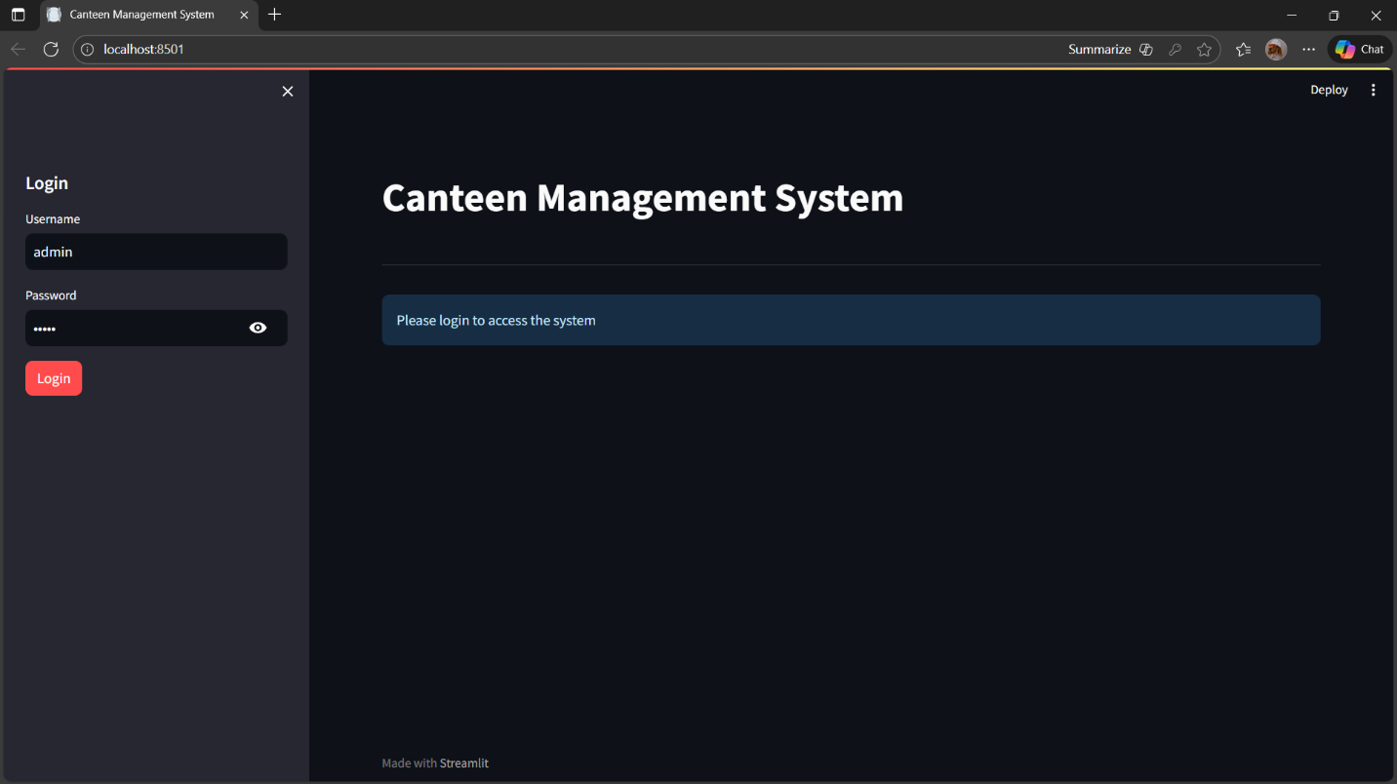
Figure 1: Login Page - Implemented in streamlit

2.2.2 Dashboard Interface
The dashboard provides a central view of the system after login. It allows navigation to modules such as Menu Management, Sales Upload, and Reports.
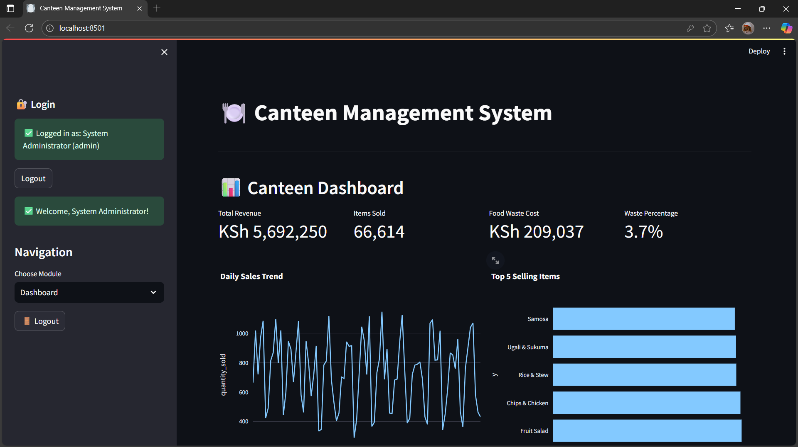
Figure 2: Dashboard Interface – Metrics and Charts.

2.2.3 Sales Entry Design
This interface allows administrators to add, edit, or delete food items. It includes a form for new entries and a table view for existing items.
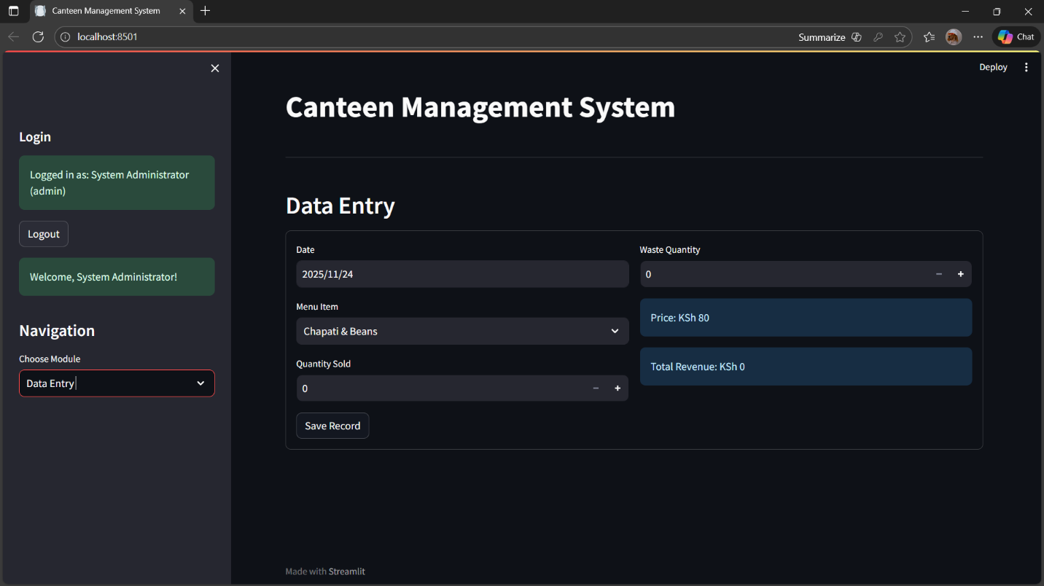
Figure 3: Sales Entry Form – Staff Interface.

2.2.4 User Management Page Design
This interface enables users to upload Excel files containing sales data. It provides a preview of uploaded records before saving.
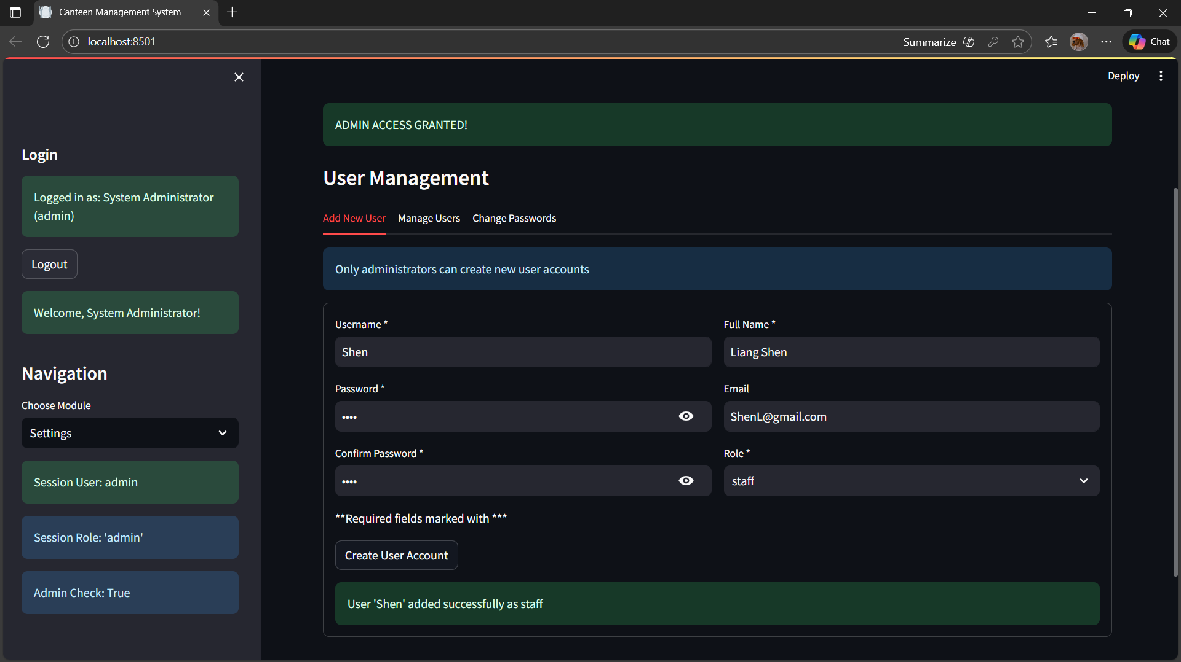
Figure 4: User Management Page – Admin Interface.

2.2.5 Reports Page Design
This interface generates summaries and charts of sales data. Users can filter reports by date range or category.
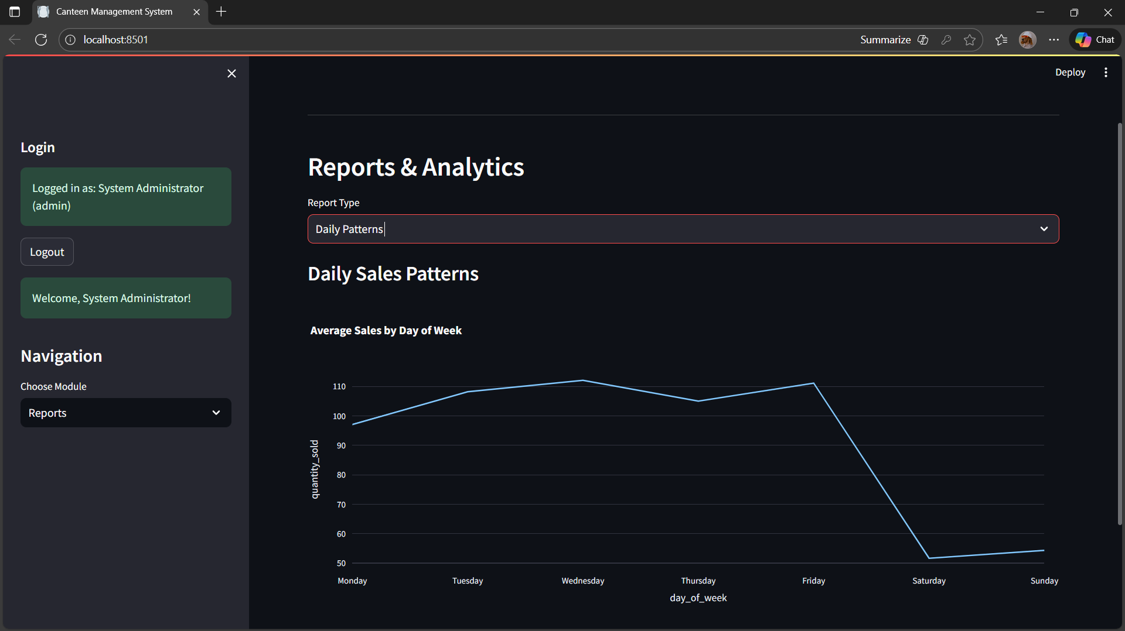
Figure 5: Reports Page – Sales Visualization.

2.3 Logic Models

2.3.1 Login Process Flowchart
Handles user login by validating credentials against stored records. Grants or denies access accordingly.
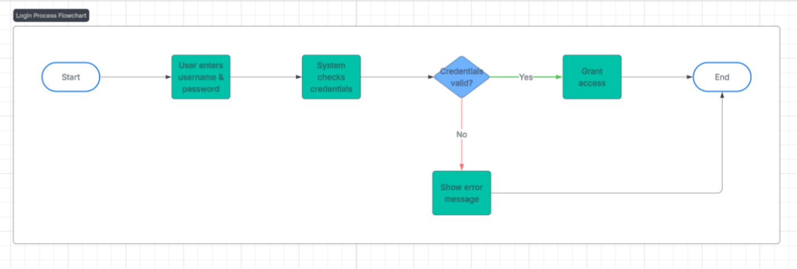
Figure 6: Login Process Flowchart.

2.3.2 Sales Recording Flowchart
Controls CRUD operations for food items. Ensures updates are reflected in the system database.
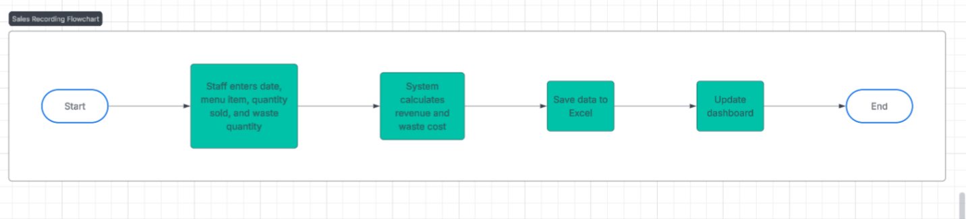
Figure 7: Sales Recording Flowchart.

2.3.3 Class Diagram for the System
Processes uploaded Excel files, validates format, and stores sales records.
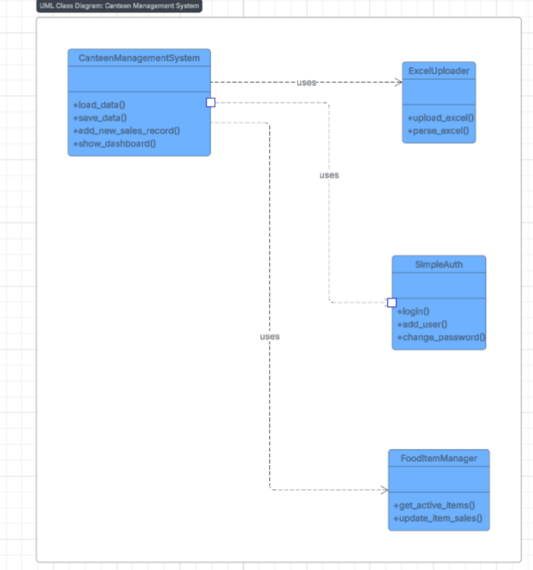
Figure 8: Class Diagram for the System.

2.3.4 Dashboard Data Flow Diagram
Aggregates sales data and generates reports with filters. Produces charts and summaries for analysis.
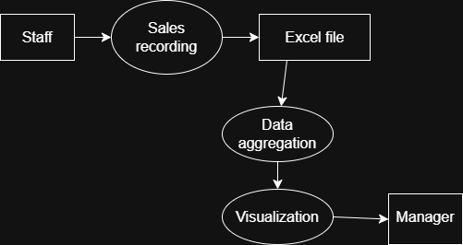
Figure 9: Dashboard Data Flow Diagram.

CHAPTER THREE: SYSTEM IMPLEMENTATION
(DEVELOPMENT, TESTING AND DEPLOYMENT)

3.1 Introduction
This chapter explains how the Canteen Management System was actually built. It shows how the development environment was set up, how the interfaces and main functions were created, how the system was tested, and how it was finally deployed. It basically covers the whole process of building, checking, and launching the project.

3.2 User Interface Development

3.2.1 Login Page Development
Allows users to authenticate before accessing the system.
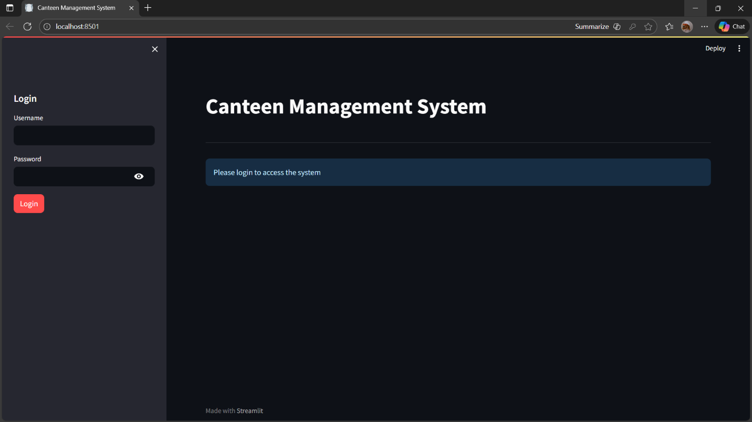
Figure 10: Login Page – User Interface.
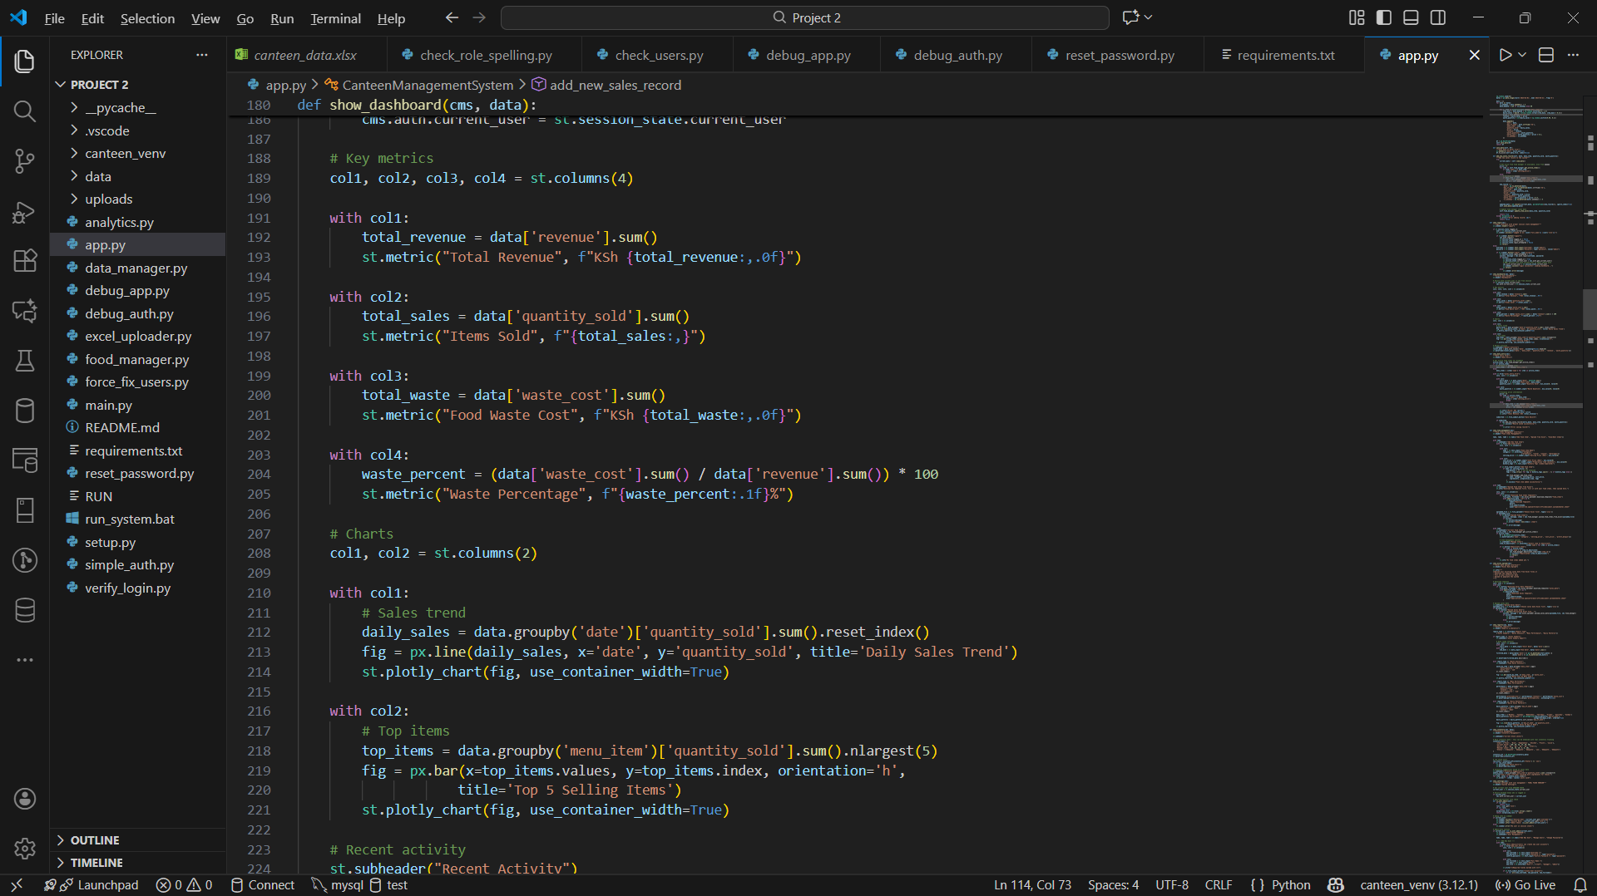
Figure 10a: Login Page – Code Implementation.

3.2.2 Sign Up Form Development
It ensures that only registered users can later log in.
Figure 11: Sign Up Form – User Interface.
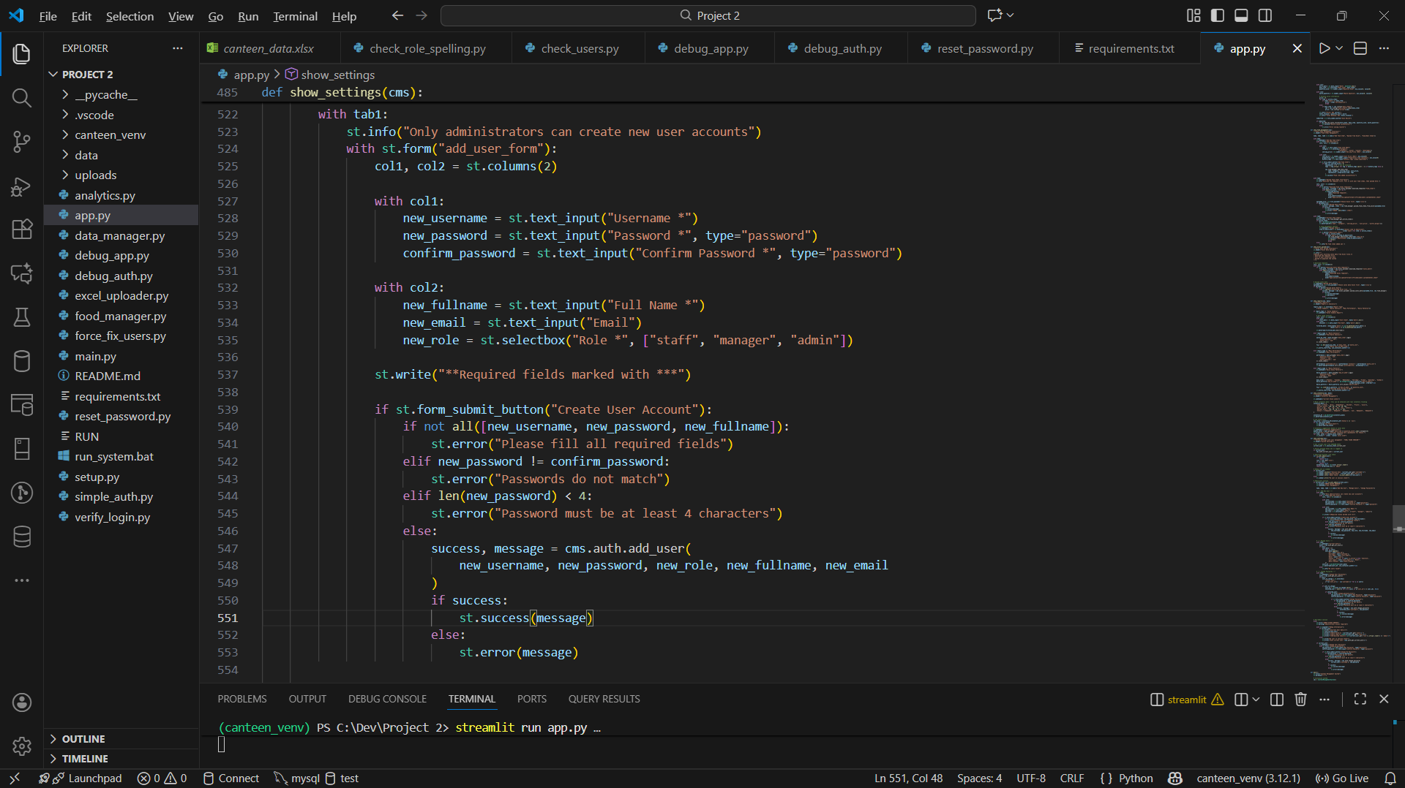
Figure 11a: Sign Up Form – Code Implementation.

3.2.3 Dashboard Development
Provides a central navigation hub after login.
Figure 12: Dashboard – User Interface.
Figure 12a: Dashboard – Code Implementation.

3.2.4 Sales Entry Form Development
Allows staff to manually record daily sales transactions into the system
Figure 13: Sales Entry Form – User Interface.
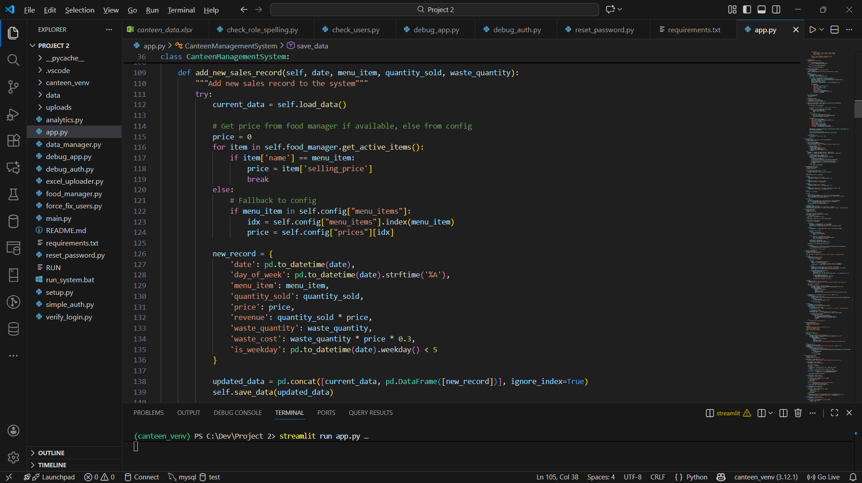
Figure 13a: Sales Entry Form – Code Implementation.

3.3 Logic Development
This section explains the backend logic that powers the system.

3.3.1 Login Validation Code
Validates user credentials and grants/denies access
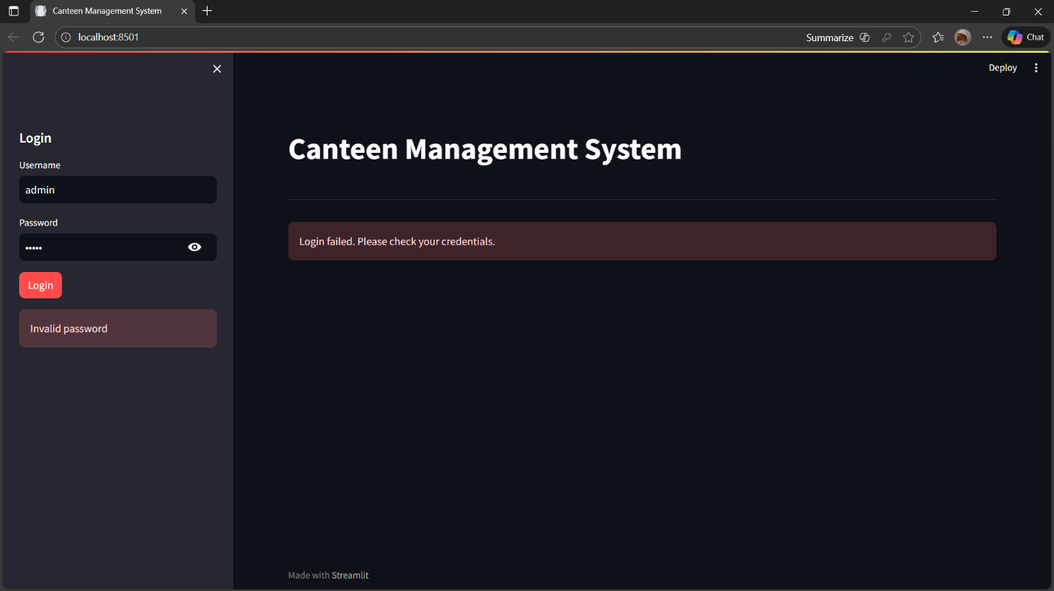
Figure 14: Login Validation Code.

3.3.2 Add User Logic
Handles CRUD operations for food items.
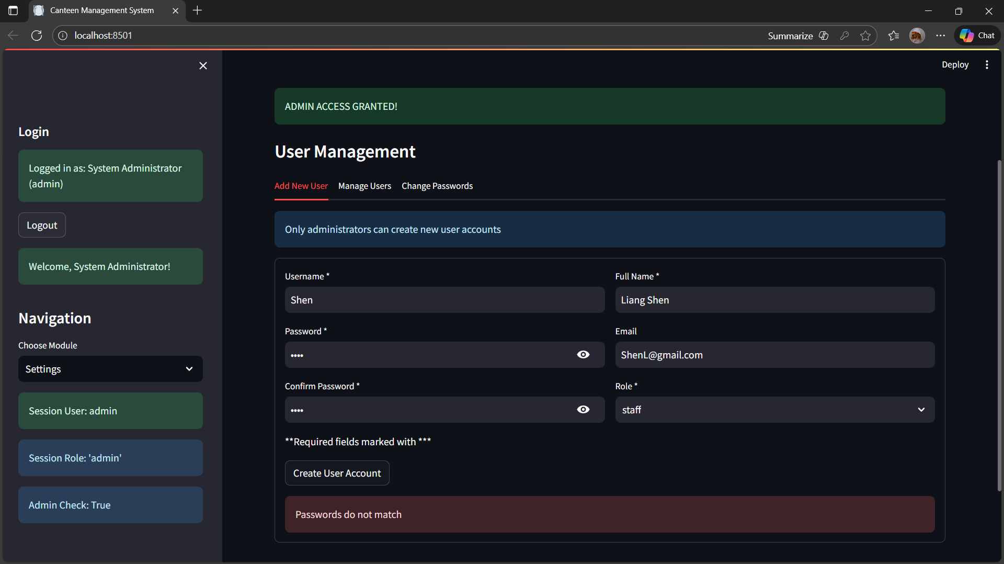
Figure 15: Add User Logic.

3.3.3 Sales Recording Logic
Processes uploaded Excel files and stores sales data.
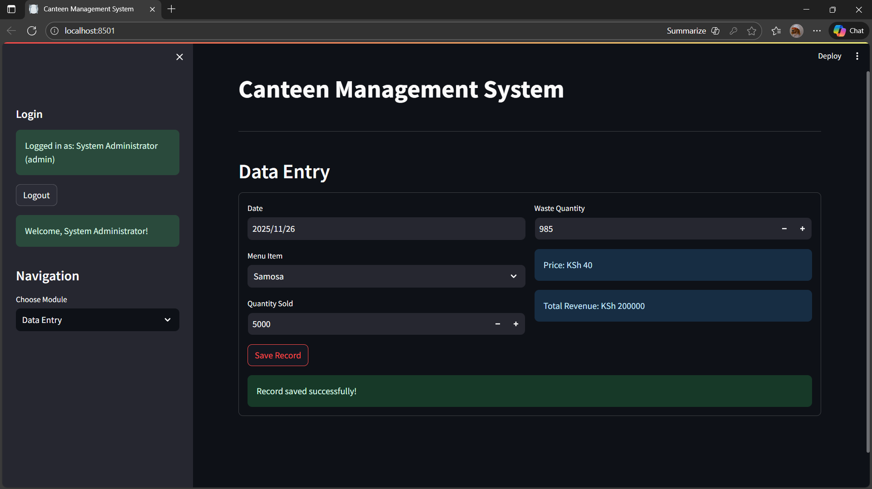
Figure 16: Sales Recording Logic.

3.3.4 Dashboard Metric Calculations
Aggregates sales data and generates reports with filters.
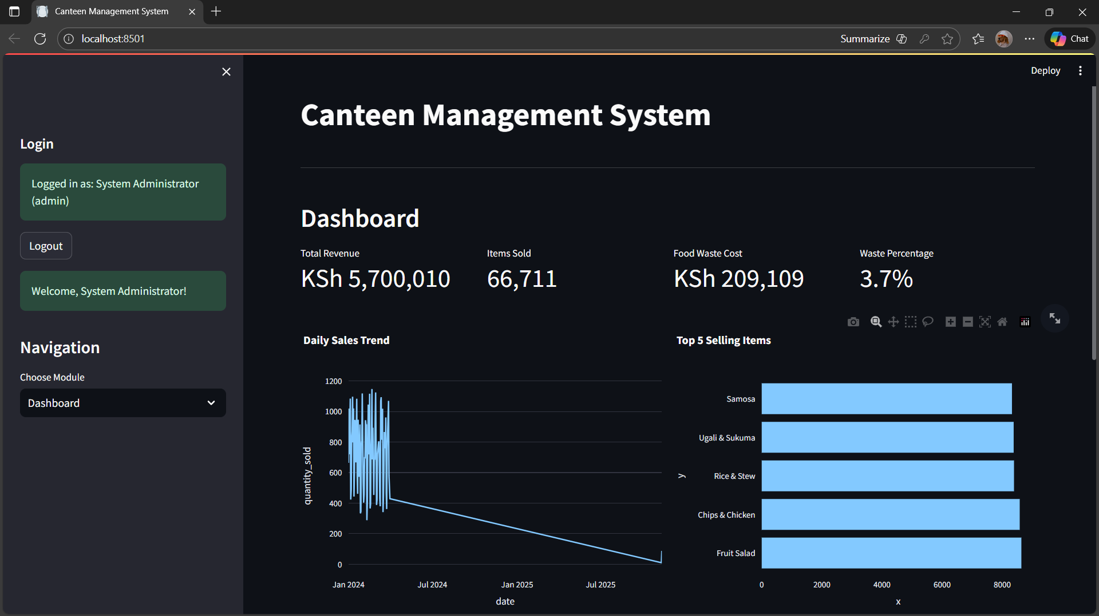
Figure 17: Dashboard Metric Calculations.

3.4 Testing
During testing, the following actions were carried out:
- Login Validation: Tested with correct and incorrect credentials to ensure only valid users gain access.
- Role-Based Access: Verified that only admin accounts can add users or access system settings.
- Sales Recording: Entered multiple sales records to confirm correct revenue and waste calculations.
- Dashboard Metrics: Checked that totals (revenue, sales, waste) update correctly with new data.
- Error Handling: Attempted invalid inputs (empty fields, mismatched passwords) to confirm proper error messages.
- Deployment Testing: Ran the system in Streamlit environment to confirm smooth navigation between modules.

3.5 Deployment
The Canteen Management System was deployed on GitHub. I set up a clean project folder, added a ‘x.gitignore’ to remove unwanted files and created a requirements.txt to list all the Python libraries. Then I initialized Git, committed all the main files, connected the project to GitHub and pushed everything to the public repo: https://github.com/Luk-ie/canteen-management-system.
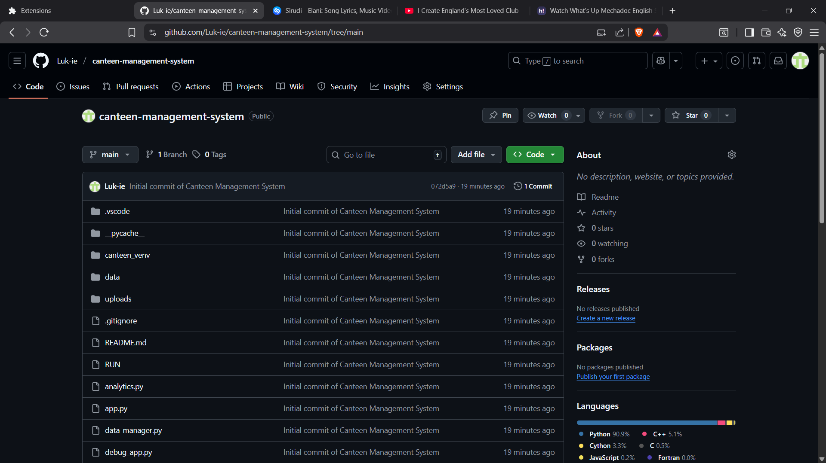
Figure 18: GitHub repository deployment of the Canteen Management System.

CHAPTER FOUR: CONCLUSION AND RECOMMENDATION

4.1 Conclusion
This project aimed to create a Canteen Management System to make sales recording, waste tracking and user management easier. Chapter One explained the problems with manual records and why a digital system was needed. Chapter Two showed the system design diagrams and Chapter Three explained how the system was built, tested and deployed. During the project, I learned a lot about Python backend work, Streamlit UI design and Plotly charts. I also learned how to fix session state bugs, handle authentication properly and write clear documentation. Some challenges were role mix-ups, keeping sessions working in Streamlit and making all the modules work well together.

4.2 Recommendation
For future developers enhancing this system, I recommend:
- Database Upgrade: Replace Excel/JSON storage with a relational database (e.g., MySQL/PostgreSQL) for scalability.
- Advanced Authentication: Integrate biometric login for staff to improve security.
- Payment Integration: Add mobile money (e.g., M-PESA) or card payment options for customers.
- Receipt Printing: Connect the system to a physical receipt printer for customers who prefer printed bills.
- Analytics Expansion: Incorporate predictive analytics to forecast demand and reduce food waste further.

REFERENCES
Lucidchart. (n.d.). How to make a flowchart. Lucid Software. https://www.lucidchart.com/pages/how-to-make-a-flowchart
Microsoft Visual Studio Code. (2024, August 12). Getting started with Python in VS Code (Official Video) [Video]. YouTube. https://www.youtube.com/watch?v=D2cwvpJSBX4
Plotly Technologies Inc. (2025). Plotly Python open-source graphing library. Plotly. https://plotly.com/python
ProgrammingKnowledge. (2023, March 5). How to install Python libraries using pip in VS Code [Video]. YouTube. https://www.youtube.com/watch?v=UZX5kH72Yx4
Tech With Tim. (2023, July 18). Top VS Code extensions for Python development [Video]. YouTube. https://www.youtube.com/watch?v=VqCgcpAypFQ
YouTube. (2025). Streamlit tutorial for beginners. YouTube. https://www.youtube.com/watch?v=JwSS70SZdyM

